
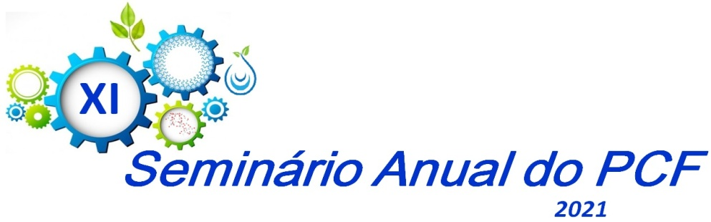



Horário | Dia 25/11 | Dia 26/11
8:15 – 8:30 h | Welcome and opening ceremony  Coordination of PCF/UEM
8:30 – 9:30 h | Conference 1  Prof. Dr. Ramesh LahiruWalpola  University of New South Wales (Australia)  Title: Medicines safety in vulnerable populations | Conference 3  Prof. Dr. Mariana KiomyOsako  Faculdade de Medicina de Ribeirão Preto (USP, Brasil)  Title: Be a mom and perish?
9:45 – 12:00 h | Simposium I: Phytochemistry  Chair: Prof. Dr. João Carlos Palazzo de Mello  Speakers:  Prof. Dr. Jackson Roberto Guedes da Silva Almeida  UNIVASF (PE, Brasil)  Title: Chemical and pharmacological study of Passiflora species from the Sao Francisco Valley  Ana CarolinaGuidi – “Poincianellapluviosa inhibits cytokine production by activated macrophages”  Clara Beatriz de Lima – “Evaluation of cytotoxicity of pyrostegiavenusta flowers in l929 cell line”  Sharize B. Galende – “In vivo experimental studies and histological analysis: methodological aspects” | Simposium II: Microbiology  Chair: Prof. Dr. Tânia Ueda Nakamura  Speakers:  Prof. Dr. Benedito do Prado Dias Filho  Universidade Estadual de Maringá(PR, Brasil)  Title: Pharmacology of natural and synthetic products: Microbiology 30 years  Elisa P. Hernandes – “Doxorubicin-loaded iron oxide nanoparticles effect in breast cancer cells”  Karina M. Retamiro – “Antitumor activity in vitro of menadione against cervical câncer”  Ludmila Pini Simões – “Inclusion of alginate microparticles containing berberine and fluconazole in pharmaceutical form cream and artificial saliva for the treatment of vulvovaginal and oral candidiasis”
14:00 – 15:00 h | Conference 2  Prof. Dr. Paulo Correia de Sá  Instituto de Ciências Biomédicas de Abel Salazar (ICBAS), Universidade do Porto (Portugal)  Title: Fine-tuning modulation of purinergic signaling dynamics: What about human diseases? | Conference 4  Prof. Dr. GracietteMatioli  Universidade Estadual de Maringá (PR, Brasil)  Title: Example of a professional journey in the University environment: life learning and knowledge transfer
15:15 – 17:30 h | Simposium III: Technology and Biotechnology  Chair: Prof. Dr. Marcos Luciano Bruschi  Speakers:  Prof. Dr. Flávio Augusto Vicente Seixas  Universidade Estadual de Maringá (PR, Brasil)  Title: “Computational biochemistry and biophysics applied to drug development”  Éverton da S. Santos–“A green strategy for enhanced phenolic compounds extraction from Cereus hildmannianus by elicitation with salicylic and jasmonic acids”  Rafaela S. dos Santos –“Mechanical properties of emulsion systems composed of Carbomer 934P, 974P or polycarbophil, natural oils and Natural bioactive agentes”  Thaila F. O. da Silva–“Characterization of phenolics compounds from leaf waste of Stevia rebaudiana” | Simposium IV: Pharmacology  Chair: Prof. Dr. Lívia Bracht  Guilherme Godoy – “Decreased docosahexaenoic acid levels in serum of HIV carrier patients”  Erika Meyer – “Cannabidiol reduces neurological deficits and glial cells activation after middle cerebral artery occlusion in mice”  Lucas Casagrande – “Microencapsulated quercetin and Bifidobacterium animalis protect huc/d-ir neurons in the submucous plexus of wistar rats chemically induced to colorectal carcinogenesis”  Round table  Egressos PCF  Dra. Andressa Blainski Pinha - Finzelberg. Alemanha  Dra. Gisely C. Lopes – Pós-doc PCF  Dra. Larissa Lachi Silva - Novartis - EUA  Dr. Rafael Pazinatto Aguiar - Boehringer Ingelheim Pharma GmbH - Alemanha

