 | 21/11/2022 and 22/11/2022 Pre-event
9:00 h - 17:00 h | Workshop: Systematic review and meta-analysis of non-clinical studies  Prof Cilene Lino de Oliveira, CFS-CCB-UFSC

 | 23/11/2022 - Pre-event
8:30 h  11:00 h – 12:00 h | Meeting of the “Multicentre preclinical study: Cannabidiol” research group  Ariandra Sartim, Kennia Moura, Francisco S. Guimarães, Gregers Wegener, Cilene Lino de Oliveira, Roberto Andreatini, Vanessa A.  Beijamini-Harres, Sâmia R. Joca,  Rúbia M. W. de Oliveira | Title: "O que cromatografia tem a ver com o recolhimento de medicamentos e alimentos das farmácias e mercados?"  Bruno Carvalho - Matrix LCMS  Title: “A Ciência no Empreendedorismo"  Dr Cindy Hana Okuma  Egresso PCF”  “Tips and tricks do doutorado sanduíche no exterior”  FORUM dos discentes do PCF

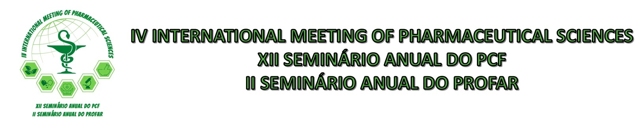

 | 23/11/2022
14:00 h – 14:10 h | Welcome and opening ceremony  Prof Dr Marcos Luciano Bruschi - coordinator PCF  Prof Dr Gislaine Franco de Moura Costa - coordinator PROFAR
14:10 h – 15:00 h | Conference 1  Title: “Uso off-label de medicamentos durante a pandemia da COVID-19: consequências desta irracionalidade”  Prof Dr Bagnólia Araújo Costa, Universidade Federal da Paraíba
15:00 h – 15:50 h | Conference 2  Title: “Functional cosmetics, nanotechnology and innovation”  Prof Dr Audrey Alessandra Stighen Garcia Lonni, Universidade Estadual de Londrina
16:00 h – 16:30 h | “3 minutes talk”
16:30 h – 17:30 h | Cultural event and coquetel

 | 24/11/2022
8:30- 9:20 h | Conference 2  Title: “Drug delivery and nanotechnology”  Prof Dr Bruno Filipe Carmelino Cardos Sarmento, Universidade do Porto, Portugal
9:20 – 10:10 h | Conference 3  Title: “Natural products with antioxidant activities for pharmaceutical applications”  Prof Dr Francisca Pinto Lisboa M. Rodrigues Sarmento, Universidade do Porto, Portugal
10:10 – 10:30 h | Coffee break
10:30 – 11:20 h | Conference 4  Title: “Biophysical insights into the binding of natural compounds to human respiratory syncytial virus proteins from experimental and computational approaches”  Prof Dr Ícaro Putinhon Caruso, Universidade de São Paulo
11:30 – 12:30 h | STUDENT’S PRESENTATIONS (4)  To be selected
12:30 – 13:30 h | POSTER SESSION
 | WORLD CUP

 | 25/11/2022
8:30- 9:20 h | Conference 5  Title: “Safe use of medicines: The Australian model of medication”  Prof Dr. Timothy Chen, The University of Sidney, Australia
9:20 – 10:10 h | Conference 6  Title: “Clinical services performed by pharmacists in the context of SUS”  Prof Dr Leonardo Regis Leira Pereira, Faculdade de Ciências Farmacêuticas da Universidade de Ribeirão Preto, USP
10:10 – 10:30 h | Coffee break
10:30 – 11:30 h | STUDENT’S PRESENTATIONS (4)  To be selected
11:30 h – 12:30h | POSTER SESSION
12:30 h – 14:00 h | Lunch
14:00 h - 14:50 h | Conference 7  Title: “Connections between art and the brain”  Prof Dr Francisco Fernandez de Miguel, Universidad Nacional Autónoma de México, México
14:50 h – 15:40 h | Conference 8  Title: “New perspectives in Parkinson disease pharmacotherapy”  Prof Dr Elaine Del Bel, Faculdade de Odontologia da USP, Ribeirão Preto, São Paulo
15:40 h – 16:10 h | Coffee break
16:10 h – 17:00 h | Conference 9  Title: “Cannabidiol”  Prof Dr Francisco Silveira Guimarães USP, Ribeirão Preto, São Paulo

SUPPORT

